Self-care isn’t selfish

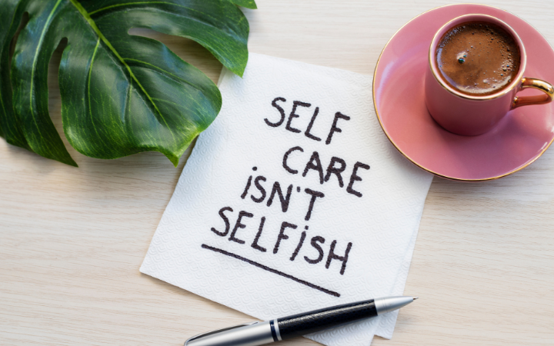
You may have heard the saying ‘you can’t pour from an empty cup’. When it comes to mental health and your wellbeing, self-care can be vital to help you recharge and take time out for yourself and your needs. If you’re constantly giving to other people, you risk burning out. Small, regular acts of self-care can have a significant impact on your mental health and wellbeing. Today we’re bringing you 4 self-care tips to help you recharge.

Sleep as self-care
Prioritise quality sleep as an act of self-care. Adults need on average between 7-9 hours of sleep every night. Getting good quality sleep is vital for our mental and physical health.

Try to create a sleep routine and go to bed at roughly the same time every night. You might want to create a little sleep ritual to help you fall asleep easily. Make your bedroom a sleep haven, keep it tidy and get the lighting right for sleep. Some people are sensitive to caffeine, so if that’s you, limit your caffeine consumption after 3pm.

It can be tempting to stay up late binge-watching a new TV series, or scrolling on your phone; however, it’s a good idea to limit exposure to screens and blue-light leading into bedtime. Instead, you could have a meditation or relaxation ritual, maybe read a book or write in a journal, or even create a skin-care routine to help you wind down.

Hydrating for good health
Staying hydrated is a simple and effective daily act of self-care. We all know that we should drink more water for our health. Our bodies need water to survive - we can’t store it or produce it. Water has so many health benefits:
- Improves mental clarity, helps brain function and increases your focus
- Aids digestion by carrying nutrients and minerals through the body
- Keeps your joints supple and lubricated
- Promote healthy, hydrated skin
- Helps to flush toxins from your vital organs

Most people need to drink around 8-10 glasses of water per day (that’s around 2-2.5L). Keep your drink bottle or glass of water handy throughout the day to ensure you are staying hydrated for your health and wellbeing.

Exercise for wellbeing and mental health
Exercise for self-care improves your mental health and wellbeing. It is estimated that 1 in 10 people worldwide live with a mental health disorder.

Research has proven that regular exercise has a positive impact on mental health:

- reduces stress, anxiety, and depression
- releases chemicals including endorphins and serotonin that improve your mood
- improves mental clarity by increasing blood flow to the brain

There are so many ways to incorporate exercise in your day: a daily walk, an early morning home yoga session, workout at the park, stretching after a long day, an exercise class or power walk with a friend.

Investing in exercise as self-care has so many positive returns. Sometimes it feels as though we don’t have the energy to exercise. We forget that exercise invigorates our minds and bodies. When it comes to exercise for self-care, we get back so much more than what we put in!

If you need some advice on prioritising your health and wellbeing, we’re here to help you to live your best life! Give us a call on [insert phone number] or email us at [insert email address] to book an appointment.

--- ENDS ---

Notes for publishers
Delete this section before printing or publishing.

What can I do with this e-mail or blog?
1. If using it as a client email, simply copy and paste the content into your email software (MailChimp etc). Insert the picture, and you’re good to send it to your email distribution list!
2. If you’re using it as a second blog, publish it to your website and check any included links are working. Then link to it from social media and your regular client email newsletter.
3. ‘Top and tail it’ bespoke to your clinic. For example, include your name, staff names, area or interests.
4. Delete from ---ENDS--- down and print it out. Pop it in your clinic waiting room or on your noticeboard.

Highlighted areas: Please delete highlighted information and insert your own as suggested.

References:

- National Institute of Mental Health (2021). Caring for your mental health. [Online]. Available at: https://www.nimh.nih.gov/health/topics/caring-for-your-mental-health (Accessed 25 May 2022).

- Health Direct (2020). Exercise and mental health. [Online]. Available at: https://www.healthdirect.gov.au/exercise-and-mental-health (Accessed 25 May 2022).
- Our World in Data (2018). Mental Health. [Online]. Available at: https://ourworldindata.org/mental-health (Accessed 25 May 2022).

